March 3, 2017

Content Dept

togglehead

Raj Mahal, 4th Floor, Veer Nariman Road, Churchgate. Mumbai – 400 020

Metro SHOES

**The Oscar Red Carpet Slayers of 2017**

The Oscar Red Carpet this year was seriously overshadowed by the infamous card-switch snafu. The beauties of tinsel town did their best to show up in all their finery, but this unfortunate event cast a dark shadow on them. But don’t you worry, we’ve got the skinny on the best looks for the Oscar Red Carpet this year, and let us tell you, it was LIT! These beauties truly stunned on the Red Carpet and it’s a bummer there’s no Academy for the Best Dressed lady. We’re happy we’re not on that committee though, because picking one would be the hardest thing we ever did! Here are our Top 5 looks from the 89th Academy Awards.

**Brie Larson**

Once you go black, you never go back! The stunner wore this asymmetrical black wonder with a plunging neckline, and we were awestruck. Take a page from her book and pair your black gown with [these gorgeous black stilettoes.](http://www.metroshoes.net/women-shoes/metro-31-7253-black-party-pumps.html)

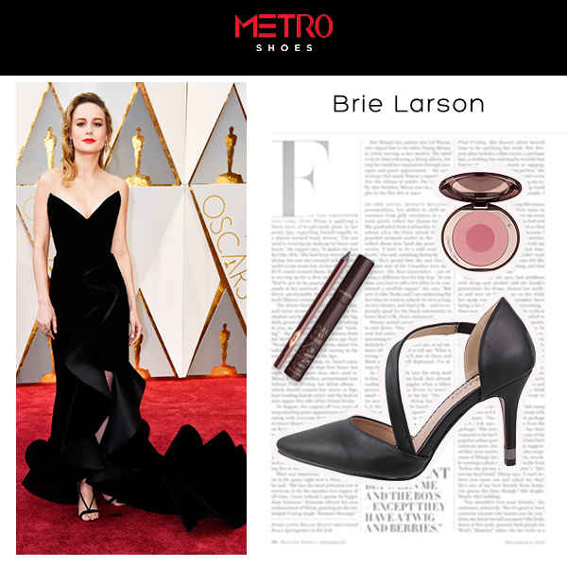

**Emma Stone**

Winner of the Actress of the Year truly took us to Gaga-land in this mid-1920s-esque layered gown. Take cues from this elegant beauty and give your gold gown a beguiling companion in the form of [these gold bejeweled heels.](http://www.metroshoes.net/women-shoes/princess-54-2507-gold-party-sandals.html)

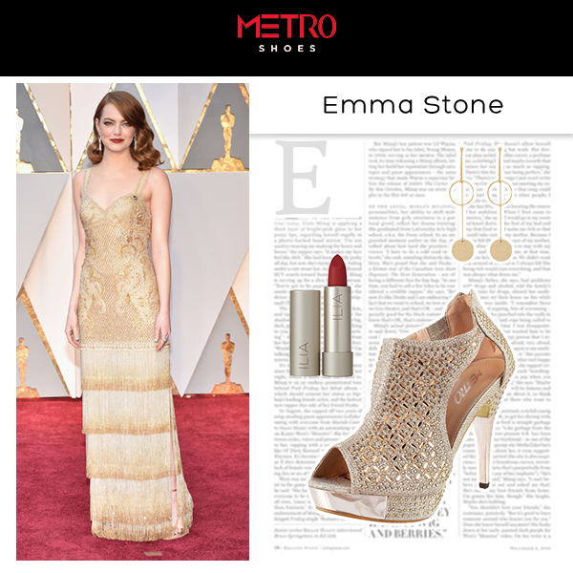

**Priyanka Chopra**

Our very own Piggy Chops repped for India in this silver and white number, and let us tell you, fashionistas everywhere were proud. Channel your inner PeeCee in [these silver caged peep toes](http://www.metroshoes.net/women-shoes/princess-54-2599-silver-party-peep-toes.html) and a pair of blingy cuffs.

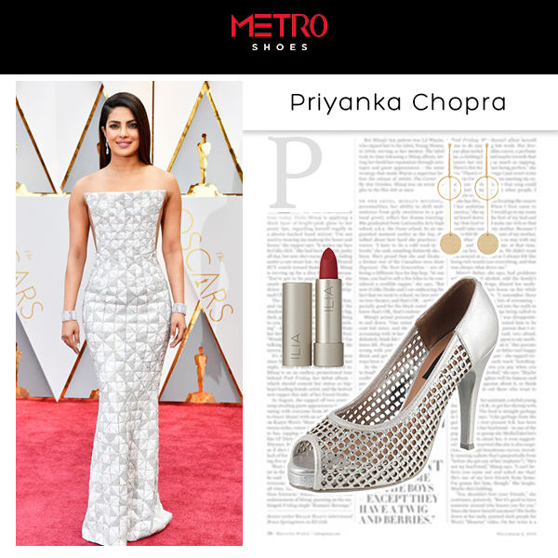

**Viola Davis**

The Best Actress in a Supoorting role won another award for her fierceness. Not one to shy away from a challenge, she rocked a red outfit on the red carpet with gusto. Take inspiration from Viola and team your red gown with [a pair of bedazzled T-strap heels.](http://www.metroshoes.net/princess-54-2595-beige-party-sandals.html)

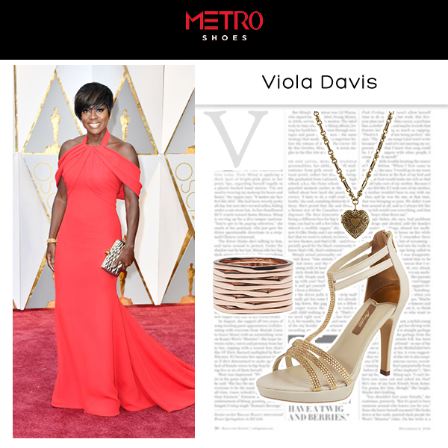

**Nicole Kidman**

Yes, we’ve all seen the memes. She may not be able to clap, but can she pull of a breathtaking pale gown? Hell, yes! Bring your A game like Nicole here in these [simple but chic gold sandals](http://www.metroshoes.net/women-shoes/metro-40-1786-gold-formal-sandals.html) when you pair them with your gown.

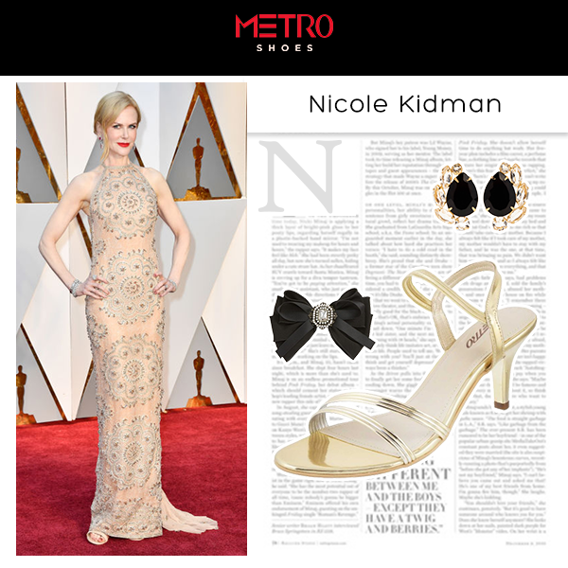

These were our favourite Oscar 2017 looks. Share with us in the comment section below if you think we’ve missed any!

P.C.- Getty Images